ГУАП
КАФЕДРА № 43
ОТЧЕТ
ЗАЩИЩЕН С ОЦЕНКОЙ
ПРЕПОДАВАТЕЛЬ
ассистент |  |  |  | И. М. Лозоватский
должность, уч. степень, звание |  | подпись, дата |  | инициалы, фамилия

ОТЧЕТ О ЛАБОРАТОРНОЙ РАБОТЕ №8

Использование функционалов в языке PROLOG

по курсу: ФУНКЦИОНАЛЬНОЕ И ЛОГИЧЕСКОЕ ПРОГРАММИРОВАНИЕ
РАБОТУ ВЫПОЛНИЛ
СТУДЕНТ ГР. № | 4236 |  |  |  | А. Панченко
 |  |  | подпись, дата |  | инициалы, фамилия

Санкт-Петербург 2024

- Задание
- Листинг кода

% Предикат для представления данных
theatrical_play(ID, TypeOfPlay, Theater, Currency, TypeOfDifference, Cost).

% Предикат для добавления записи
add_theatrical_play(ID, TypeOfPlay, Theater, Currency, TypeOfDifference, Cost, Map, NewMap) :-
NewMap = [theatrical_play(ID, TypeOfPlay, Theater, Currency, TypeOfDifference, Cost) | Map].

% Предикат для удаления записи
delete_theatrical_play_by_id(ID, Map, NewMap) :-
select(theatrical_play(ID, _, _, _, _, _), Map, NewMap).

% Предикат для обновления записи
update_theatrical_play(ID, TypeOfPlay, Theater, Currency, TypeOfDifference, Cost, Map, NewMap) :-
delete_theatrical_play_by_id(ID, Map, TempMap),
add_theatrical_play(ID, TypeOfPlay, Theater, Currency, TypeOfDifference, Cost, TempMap, NewMap).

% Предикат для вывода данных
print_theatrical_play(theatrical_play(ID, TypeOfPlay, Theater, Currency, TypeOfDifference, Cost)) :-
(var(ID) ->
format("ID: not specified~n");
format("ID: ~w~n", [ID])
),
format("Type of play: ~w~n", [TypeOfPlay]),
format("Theater: ~w~n", [Theater]),
format("Currency: ~w~n", [Currency]),
format("Type of difference: ~w~n", [TypeOfDifference]),
format("Cost: ~w~n~n", [Cost]).

% Предикат для поиска по заданному критерию
search_theatrical_play(Map, Field, Value) :-
member(theatrical_play(ID, TypeOfPlay, Theater, Currency, TypeOfDifference, Cost), Map),
(Field = 'theatrical-plays-type-of-play', TypeOfPlay = Value;
Field = 'theatrical-plays-theater', Theater = Value;
Field = 'theatrical-plays-id', ID = Value;
Field = 'theatrical-plays-currency', Currency = Value;
Field = 'theatrical-plays-type-of-difference', TypeOfDifference = Value;
Field = 'theatrical-plays-cost', Cost = Value),
print_theatrical_play(theatrical_play(ID, TypeOfPlay, Theater, Currency, TypeOfDifference, Cost)),
false. % продолжаем поиск

search_theatrical_play(_, _, _). % остановка если ничего нет

% Запуск
:- initialization(main).

main :-
% Инициализация данных
Map = [
theatrical_play(1, drama, 'Broadway', usd, reverse, 2500),
theatrical_play(2, comedy, 'WestEnd', eur, straight, 1000),
theatrical_play(3, musical, 'Royal Opera House', usd, reverse, 3500)
],

% Вывод начальных данных
write('Begin'), nl,
maplist(print_theatrical_play, Map), nl,

% Тест добавления
write('Test Adding'), nl,
add_theatrical_play(4, tragedy, 'WestEnd', rub, reverse, 4000, Map, NewMap),
maplist(print_theatrical_play, NewMap), nl,

% Тест обновления
write('Test Updating'), nl,
update_theatrical_play(4, tragedy, 'WestEnd', rub, straight, 4000, NewMap, UpdatedMap),
maplist(print_theatrical_play, UpdatedMap), nl,

% Тест удаления
write('Test Deleting'), nl,
delete_theatrical_play_by_id(3, UpdatedMap, DeletedMap),
maplist(print_theatrical_play, DeletedMap), nl,

% Вывод всех данных
write('All Data'), nl,
maplist(print_theatrical_play, UpdatedMap), nl,

% Поиск по критериям
write('Finding for type of play (comedy)'), nl,
search_theatrical_play(UpdatedMap, 'theatrical-plays-type-of-play', comedy), nl,

write('Finding for cost (4000)'), nl,
search_theatrical_play(UpdatedMap, 'theatrical-plays-cost', 4000), nl,

write('Finding for Theatre (WestEnd)'), nl,
search_theatrical_play(UpdatedMap, 'theatrical-plays-theater', 'WestEnd'), nl,

write('Finding for id (2)'), nl,
search_theatrical_play(UpdatedMap, 'theatrical-plays-id', 2), nl,

write('Finding for currency (usd)'), nl,
search_theatrical_play(UpdatedMap, 'theatrical-plays-currency', usd), nl,

write('Finding for type of difference (reverse)'), nl,
search_theatrical_play(UpdatedMap, 'theatrical-plays-type-of-difference', reverse), nl,

halt.

- Результат работы программы

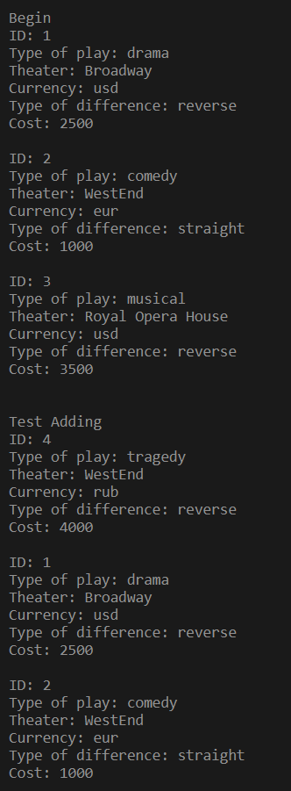
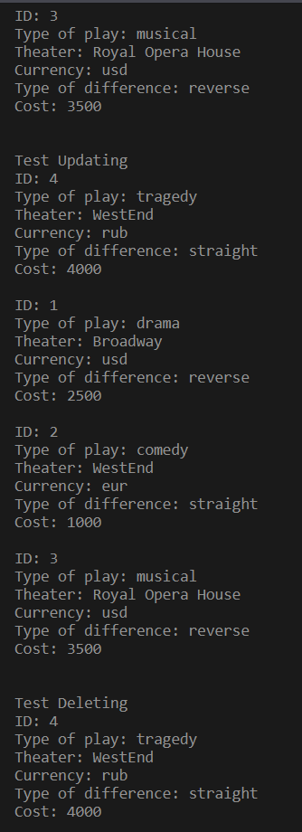
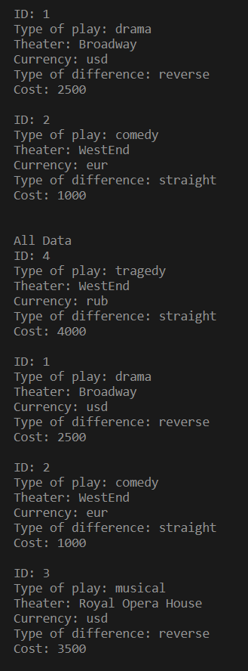
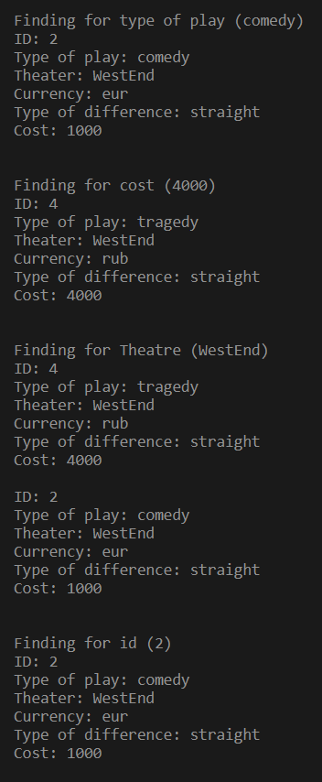
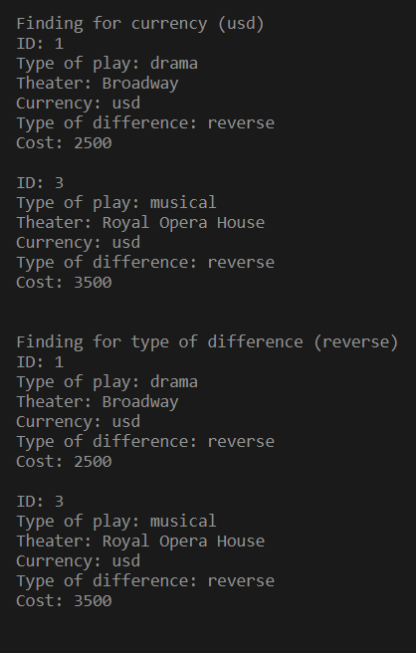

- Вывод

В ходе данной лабораторной работы я ознакомился с применением функционалов в языке Prolog.

